Welcome to Wimbledon Mobile Mechanic  A quality Service at your Service | 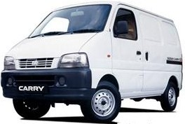
The W M M is a idea which provide you a hope without interring your car to garage or even more

W m m offers :
 | Quality service to your door |  | Wrong fuel contamination
 | Diagnostic facilities during works |  | No job too small
 | 24 / 7 Recovery Service |  | Break down emergency
 | Road side assistance |  | Reasonable pricing
AND MUCH MORE...

